Wall Street Journal
http://online.wsj.com/article/SB10001424052748704904604576333282516944112.html#

A Dutch Master Returns
By KAREN WILKIN
Washington

In the 18th century, the best-informed dealers and collectors would have counseled against buying a Vermeer if a Metsu was available. Today, while the name Johannes Vermeer guarantees record crowds at any exhibition, that of his contemporary Gabriel Metsu is familiar mainly to serious devotees of Dutch Golden Age painting. During the past year, however, Metsu may have reclaimed some of his former renown, thanks to a tightly focused and informative touring exhibition jointly organized by the National Gallery of Ireland, Dublin; the Rijksmuseum, Amsterdam; and the National Gallery of Art, Washington, where we can now discover this once-acclaimed master for ourselves.

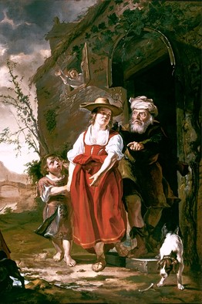 Stedelijk Museum De Lakenhal/Vereniging Rembrandt 'The Dismissal of Hagar' (1653-54), pictured here, and 'A Woman Reading a Letter' (1664-66)—examples of two thematic extremes.

According to Arthur K. Wheelock Jr., the National Gallery's curator of northern baroque painting and the show's coordinator, the exhibition attempts to deal with "the problem of Metsu"—that is, to make sense of the many diverse types of pictures he produced during his relatively brief career. (Born in 1629, he died in 1667.) In Washington, the modest number of Metsus on view includes religious subjects, moralizing genre scenes, risqué dramas, portraits, self-portraits, a city view, arcane symbolic compositions, glorifications of youthful charms, studies of old age, and more. This range is surprising in an era when Dutch artists tended to be pragmatic specialists, known as portrait or history painters (including religious and mythological subjects) or as authors of scenes of everyday life, marine views or cityscapes. Prof. Wheelock speculates that Metsu's atypical, restless investigation of different approaches may indicate a canny sense of what would today be called "niche marketing"—testing the Dutch art-buying public's appetites as he aimed at establishing himself as someone to be reckoned with, first in his native Leiden and then in Amsterdam; he might have, for example, explored how Amsterdammers responded to picturesque Leiden-style images of elderly women and then tried something else if interest waned.
This multiplicity also applies to manner. Metsu could convincingly evoke many of the other leading painters of the period. He certainly prided himself in his virtuoso ability to render textures with paint, filling his works with shimmering silks, thick woolens, soft fur, gleaming metal and glass, humble earthenware—so he could also have been eager to show himself capable of tackling any type of picture.
Two religious paintings bracket the National Gallery's handsome installation: "The Dismissal of Hagar" (c. 1653-54), the earliest work in the show, and a crucifixion, painted in 1664. In the former, Hagar, a buxom young woman in red, and her anxious son, Ishmael, are ushered from the house by a turbaned Abraham, while Sarah shrieks from an upstairs window. The large canvas and ample figures, as well as the biblical theme, suggest Italianate sources, something not readily available in Leiden to an aspiring artist, but accessible in Utrecht, home of a group of Dutch painters influenced by Caravaggio. That Metsu was Catholic and Utrecht a Catholic stronghold in Protestant Holland makes it more likely that he studied there.
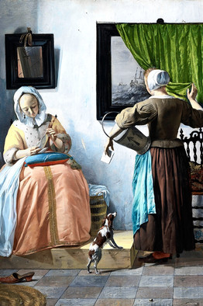 National Gallery of Ireland
'A Woman Reading a Letter' (1664-66)

At the opposite thematic extreme are Metsu's best-known genre works, the National Gallery of Ireland's "A Man Writing a Letter" and "A Woman Reading a Letter" (both c. 1664-66). They are his most "Vermeer-like" efforts, with the figures, in tile-floored rooms bathed in cool light, seated in shallow stagelike spaces defined by paintings and mirrors hung behind them. Yet despite the (deliberate) similarities with Vermeer's "signature" imagery—including the woman's yellow, fur-trimmed jacket—the Metsus seem more casual and anecdotal, less timeless and geometrically inevitable than the work of his now more celebrated colleague.
Which brings us to what Prof. Wheelock calls the really interesting question, given the painter's chameleon qualities and multiple subjects: "What makes a Metsu a Metsu?" One answer is "sumptuous color." Vibrant reds, luminous blues, arresting whites, lush apricots and golds glow against dark backgrounds. Drawn by this visual richness, we soon become engaged by Metsu's other distinguishing characteristic: his gift as a storyteller. Every detail in the paintings contributes to their absorbing narratives. A light-struck beaker of wine beside an old woman enjoying a frugal meal triggers associations with the Eucharist. We notice the ambiguous response of a woman offered game by a hunter (an earthy double-entendre in Dutch), as she slips off a shoe and reaches for her Bible.
We are engaged, too, by the implications of Metsu's work. A dead rooster hung upside down, white feathers looming against darkness, points to Chardin, as does a kitchen maid peeling apples, reminding us of Metsu's 18th-century eminence. A tender portrait of a mother cradling an ailing child becomes a vernacular pietá, pointing back to the disguised symbolism of Netherlandish Renaissance painting. But it's Metsu's quirky range that delights us most. Witness the truly odd "Hunter Getting Dressed After Bathing" (c.1654-56), the only nude self-portrait, I am reliably told, in Dutch painting. All this and a readable, fascinating catalog.

Ms. Wilkin writes about art for the Journal.

